Inhaltsverzeichnis
1 Important Note 2
2 Introduction 2
3 Objectives of the packaging guideline 2
4 General packaging requirements 3
5 Specific packaging requirements 3
5.1 Recycling Codes 4
5.1.1 Plastics 5
5.1.2 Paper and Cardboard 6
5.1.3 Metals 6
5.1.4 Wooden Materials 6
5.1.5 Textiles 7
5.1.6 Glass 7
5.1.7 Composite Materials 7
5.2 Construction of Packaging 8
5.2.1 Construction Requirements Traypackaging 8
5.2.2 Construction Requirements Blisterpackaging 8
6 Sustainability 8
7 General Requirements for goods delivered on pallets 8
8 Specific Requirements for goods delivered on pallets 9
9 Packaging requirements 12
9.1 Requirement for the packaging of electronic components (ESD-protected components) 12
10 Full Container Loads (FCL) 13
11 Handling Requirements 13
12 Shipping Documents 13
13 Marking of Cargo 14
14 Delivery Address 15
15 Opening hours Receiving Department 15
16 Failure to comply with packaging guideline 15
17 Contact Information 15

Important Note
This packaging guideline will be reviewed and updated regularly.
There will be no notifications of changes issued. We nevertheless require our partners to comply with the most recent version.
To assure compliance please check our website for the most recent version at www.bjb-com
This guideline is valid for all deliveries to BJB. Exemptions need prior approval by BJB.

Introduction
BJB GmbH & Co. KG has been a successful development and innovation partner in the lighting and household appliance industry since 1867.

To remain internationally competitive BJB focuses on a continuous improvement strategy for all departments and processes. This packaging guideline was established in 2011 as a contribution of the Logistic Department to our continuous improvement program.

It applies to our high-quality products as well as logistics which includes material flow, packaging, transportation and handling. The packaging guideline describes our requirements to enable our suppliers to develop the best possible and environmentally friendly packaging system for our products. The supplier is responsible to deliver the goods safely, in time and without any damages. Please share the following requirements with all employees involved in the packaging and delivery process.
Unless otherwise agreed upon in individual contracts, deliveries to our company are made according to our General Terms and Purchasing Conditions as well as the additional BJB packaging guideline for all supplied parts. Incoming deliveries are subject to incoming inspections which includes a check for compliance to our packaging guideline.
In case of noncompliance, BJB GmbH & Co. KG reserves the right to charge back costs incurred for providing suitable packaging or to reject the entire delivery.
Also non-compliance has a negative impact on the annual supplier evaluation.

Objectives of the packaging guideline
Involvement of suppliers in continuous improvement processes:
- Communication of requirements of BJB GmbH & Co. KG
- Strengthening the sense of responsibility of suppliers
- Avoid delays in deliveries
- Compliance with occupational health and safety requirements and environmental protection regulations
- Ensure a smooth material flow
- Avoid transportation damages

General packaging requirements
Regardless of the type of packaging chosen, the following requirements have to be met:
- Packages have to be clearly labeled
- The choice of packaging is to be made considering environmental and quality aspects
- The choice pf packaging has to be appropriate tot he delivered goods and the method of shipment (Oversized packaging has to be avoided)
- Optimized space utilization of packaging unit
- Packaging units / boxes have to be stackable (min. 2 layers))
- Attention! If boxes are not stackable or do not exactly fit the pallet it has to be clearly marked on the outside of the packaging.
- If possible pallets should contain only products of the same partnumber
- The usage of one-way packaging materials has to be reduced to its minimum
- Compliance with permitted / recommended lifting load
(see page 4)
- Exemptions can be made on an individual basis and need prior approval by BJB
- Deviations of this packaging guidelines will be recorded, communicated to the supplier and are subject to further actions

Specific packaging requirements
- Marking of all packaging materials according to EU Guideline 97/129/EG
- Prohibit use of printing ink which contains mineral oil according to French Law AGEC
- Compliance with Packaging and Packaging Waste Regulation (PPWR) 2025/40
- Compliance with European Union Deforestation Regulation (EUDR)
- Exclusive supply of technically sulfur-free packaging (paper/corrugated board)

- Requirements of single-use packaging:
- It is the supplier`s responsibility to select a proper packaging for the goods shipped.
- The following requirements need to be considered for the selection of packaging:
- only clean and undamaged single-use packaging can be used
- the packaging materials must be recyclable
- if possible all single-use packaging materials have to be marked with RESY sign.
- cushioning materials have to be used if necessary
Please avoid using lose cushioning materials such as peanuts or newspaper. We recommend using bubble wrap or wrapping paper.
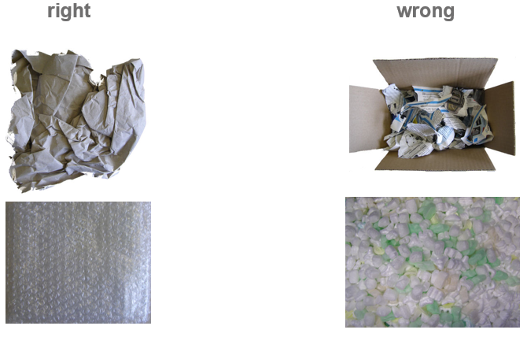

- For easier identification of materials used, they should be labled and structually arranged. If necessary separating inserts should be used.
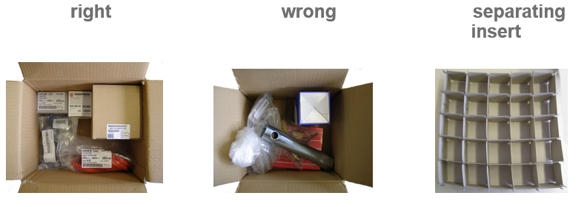
- The partnumber must be easily visible when opening the package.
- To ensure smooth and occupational safety compliant handling, each package should not exceed a gross weight of 20 kg.

Recycling Codes
Marking according to EU Guideline 97/129/EG

Plastics
Code-Nr. | Abbreviation | Description
 | PET | polyethylenterephtalate
 | HDPE | high density polyethylene
 | PVC | polyvinylchloride
 | LDPE | low density polyethylene
 | PP | polypropylene
 | PS | polystyrene

Paper and Cardboard
Code-Nr. | Abbreviation | Description
 | PAP | corrugated cardboard
 | PAP | miscellaneous cardboard
 | PAP | paper

Metals
Code-Nr. | Abbreviation | Description
 | FE | iron/steel
 | ALU | aluminimetallum

Wooden Materials
Code-Nr. | Abbreviation | Description
 | FOR | wood
 | FOR | cork

Textiles
Code-Nr. | Abbreviation | Description
 | TEX | cotton
 | TEX | jute

Glass
Code-Nr. | Abbreviation | Description
 | GL | clear glass
 | GL | green glass
 | GL | brown glass

Composite Materials
Code-Nr. | Abbreviation | Description
80 | C/* | paper and cardboard / misc. metals
81 | C/* | paper and cardboard / plastics
82 | C/* | paper and cardboard / aluminium
83 | C/* | paper and cardboard / tin
84 | C/* | paper and cardboard / plastics / aluminium
85 | C/* | paper and cardboard / plastics / aluminoium / tin
90 | C/* | plastics / aluminium
91 | C/* | plastics / tin
92 | C/* | plastics / misc. metals
95 | C/* | glass / plastics
96 | C/* | glass / aluminium
97 | C/* | glass / tin
98 | C/* | glass / mics. metals
* Abbreviation of the main ingredient

Construction of Packaging

Construction Requirements Traypackaging
Construction Requirements for tray packaging (BJBDE-#4333180 (DE), BJBDE-#5691003 (EN)) can be requested if needed.

Construction Requirements Blisterpackaging
Construction according to DIN EN IEC 60286-3.

Sustainability
Sustainable packaging solutions have to be considered and preferred if they make economically sense and/or are necessary/feasible/justifiable.
This applies to both sustainable packaging materials and reusable packaging solutions.
Reusable packaging solutions are specifically important for regularly exchanged goods in supplier-customer relationships.

General Requirements for goods delivered on pallets
- Only used damage-free pallets
- Euro pallets are only accepted in exchangeable condition
- Sufficient fork clearance between the pallet feet
- Ensure proper protection of packaged goods
- Load carrier must maintain transport loads
- Ensure stack ability of cargo (min. 2 layers)
- Marking according to IPPC (heat treated)
- Basic dimension of loading unit cannot be exceeded
- Cargo cannot stick out of the pallet
- Attention! If stacking is not possible, this must be clearly
marked on the cargo.

Specific Requirements for goods delivered on pallets

- Euro pallet
Only use Euro pallets in exchangeable condition.
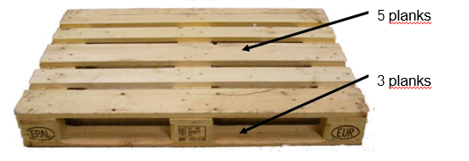
- Notes on marking
According to currently valid guideline Euro pallets with the following markings have to be used:

- Dimensions / Load Capacity
Measurement WxLxH 800 mm x 1200 mm x 144 mm
Load Capacity: 1200 kg
- Additonal Information
Most current regulations can be found at http://www.gpal.de.
- re-usable flat pallets / single-use pallets
Re-usable flat pallets or single-use pallets can be used exceptionally if agreed upon with BJB. The dimensions must be identical to Euro pallets.
Attention!
If there is no individual agreement, Euro pallets have to be used for a weight load exceeding 250 kg. If the product geometry, e.g. for belt material or heavy goods parts, requires a deviation from the previously described requirements, special pallets must be used which ensure the proper delivery of the goods.
Under all circumstances it must be ensured that the pallets can be picked up by forklifts from at least two side (see page 10f).
- Securing loading units
The loading units should be secured in a way to guarantee undamaged delivery.
The goods must be protected from slipping, external influences (moisture) and other possible damages. We recommend the use of strapping tape, stretch wrap and shrink wrap (see page 10f).
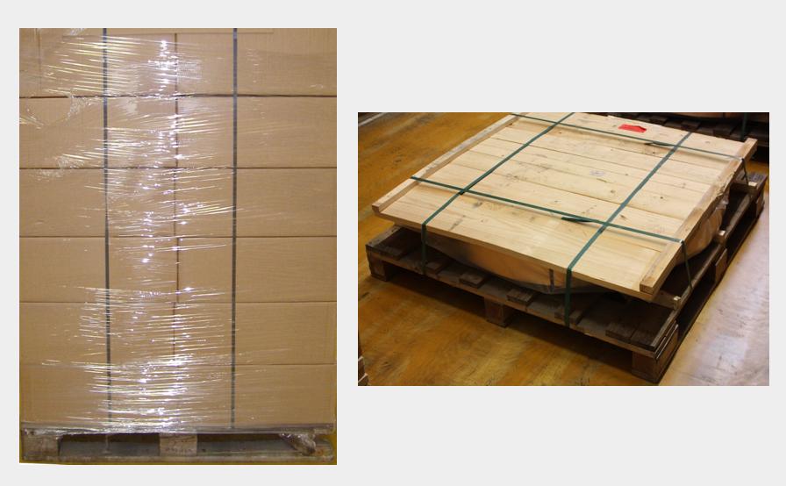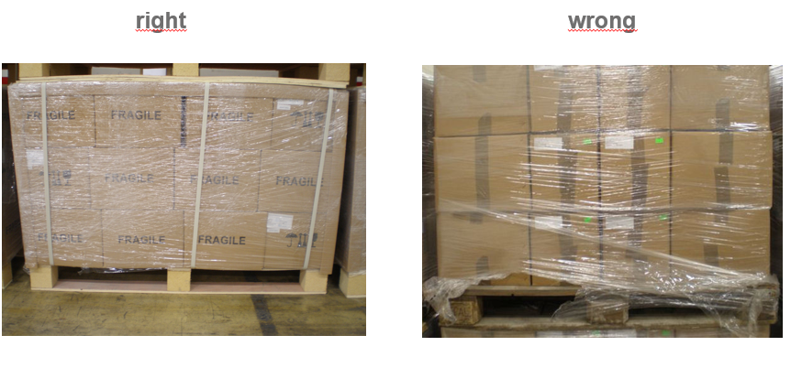

- Formation of loading units
It has to be ensure that transportation with one of the below mentioned vehicles is possible:


Attention!
To ensure easy handling the free space between the pallet feet cannot be covered with shrink wrap.
The loading units have to be evenly spread on the pallet to enable at least two layer stacking and create stability.
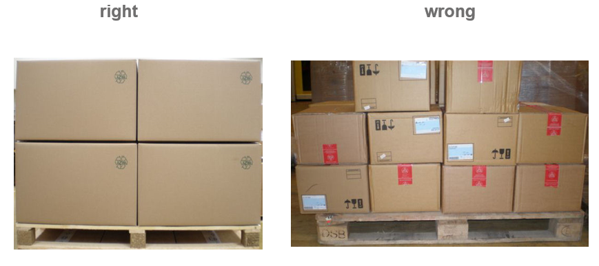
The max. height of 980 mm cannot be exceeded.
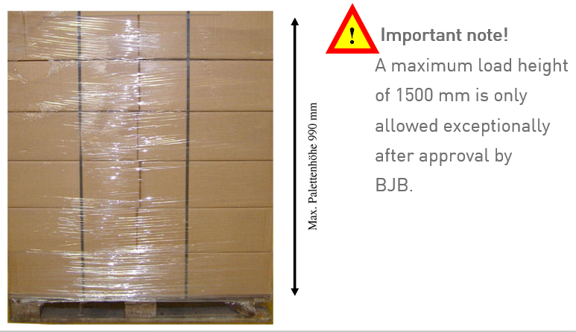

Packaging requirements
• Sealing
The cartons must be sealed with two adhesive tapes applied slightly offset and overlapping on the sides.
Failure to overlap the tape may result in the seal coming off.
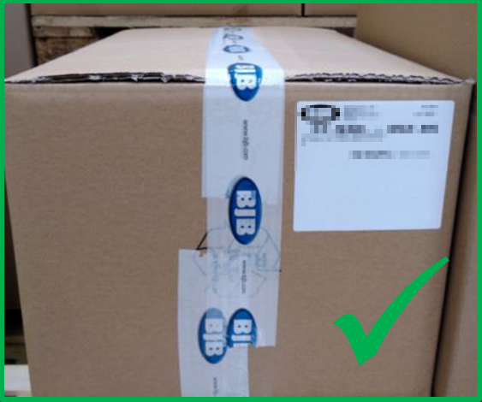
The adhesive strips must not be applied in a cross pattern.
For square cartons, the flaps on the top and bottom must be folded and taped the same way.

• Labeling
Cartons may only be labeled with the weight of the entire pallet or the individual package. Other markings or notes are not allowed.

Requirement for the packaging of electronic components (ESD-protected components)
The sourcing of electronic components involves sensitive components with high requirements on the packaging. Especially for ESD protected components there are more stringent requirements. All suppliers have to be compliant with the regulations of DIN EN 61340-5. For the specific requirements of electrical components please see DIN EN 61340-5-3. It is the supplier`s responsibility to mark and protect the components and its packaging according to this regulation.
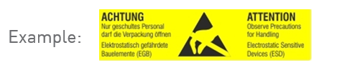
Attention:
In order to comply with the above-mentioned standard, we recommend that you check the finished packaging before it leaves your company using the most recently approved test methods. Additionally, we recommend that you train all employees in your company handling such components on ESD protection.

Full Container Loads (FCL)
- Loading of Container
When loading the container it has to be ensured that the goods arrive safely.
Goals of optimized container loading:
- Securing the goods against tipping and sliding.
We recommend to not leave any free spaces when loading the container. If the container cannot be entirely filled with products please use reasonable commercially available filling materials.

Handling Requirements
If special handling requirements apply for your deliveries to BJB, please attach them easily viable on three side of the cargo using the symbols below:.
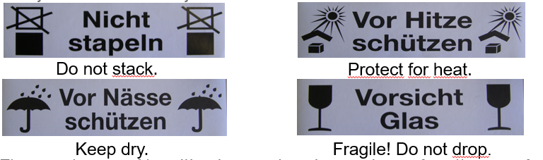
Please make sure to apply the markings on all packaging units shipped..
Attention:
Special attention must be paid to the delivery of hazardous substances.
Our employees must be made aware of these by applying appropriate symbols on the packaging. A safety data sheet must also be enclosed with each shipment.

Shipping Documents
- Shipping documents (e.g. Delivery Note and Shipping Order) have to be placed into a delivery note bag outside on the first packaging unit.
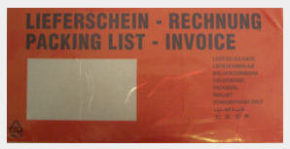
- When delivering plastic and strip material, quality test certificates must also be enclosed with the shipment or sent electronically before delivery to the known recipients in-house.
Attention!
Documents that require special attention (e.g. duty related documents) have to be submitted prior to delivery. They should be marked „important documents“.
- Delivery Note
Please list the following information on your delivery note:
- BJB PO Number
- Contact information of the shipper
- BJB partnumber (if know and printed on the PO)
- Samples shipments: Name of requested employee, Department, Cost Center
- Material description
- Total delivered QTY and QTY each packaging unit
- No of packaging units (number each unit from 1 to x)
- Contact information BJB (BJB Purchasing Department; for details please see PO)
A copy of the printed delivery note has to be attached to the shipment in German and English language.
These requirements apply to ALL deliveries independently of the packaging or shipping method used.

Marking of Cargo
A label has to be attached to each packaging unit containing the following information:
- entire BJB part number (11 digits)
- Number of packaging unite (1 to x)
- QTY
- Supplier
- BJB PO number
- BJB Part description
- Date of production and shipping date
- Country of Origin

Does a shipment contain of more than one package, please make sure to label all packages. Labels have to be attached to 3 sides of the package, in German and English language.

Delivery Address
If not otherwise indicated on the PO, please deliver to:
BJB GmbH & Co. KG
Receiving Department
Werler Straße 1
D - 59755 Arnsberg (Neheim)
Germany

Opening hours Receiving Department
Hours
Monday thru Thursday 07.30 AM – 02.00 PM
Friday 07.30 am – 12.30 PM
Deviations / Exceptions
We will announce deviations or exceptions to this schedule in time by:
- printing a note on our POs
- Notices in our Receiving Department
- Announcement by Purchasing Department of BJB
Attention!
Silo deliveries can only be made by 12.30 or prior agreement.

Failure to comply with packaging guideline
- The employees of BJB GmbH & Co. KG will check all deliveries according to compliance with the specifications of this BJB Packaging Guideline.
- Failure to comply without individual agreement between supplier and BJB may lead to return of this shipment or chargeback of the additional expenses.
- A negative deviation from this specifications always leads to a lower rating in the supplier evaluation.

Contact Information

Purchasing
Mr. Timo Hildebrand
Phone No: 02932 982-527
E-Mail: Timo.Hildebrand@bjb.com

Packaging Manager
Mr. Jörg Michel
Phone No: 02932 982-564
E-Mail: Joerg.Michel@bjb.com

